**Project 2**

**Decision Trees**

|  |  |  |  |  |  |  |  |
| --- | --- | --- | --- | --- | --- | --- | --- |
| **α/α** | **Algorithm** | **Criterion** | **Max depth** | **Accuracy** | **Precision** | **Recall** | **F1** |
| 1 | Decision Tree | entropy | 2 | 0.9202 | 0.9266 | 0.9016 | 0.9212 |
| 2 | Decision Tree | entropy | 3 | 0.9148 | 0.9162 | 0.9772 | 0.9122 |
| 3 | Decision Tree | entropy | 4 | 0.9255 | 0.9271 | 0.9237 | 0.9259 |
| 4 | Decision Tree | gini | 2 | 0.8617 | 0.8792 | 0.9814 | 0.8570 |
| 5 | Decision Tree | gini | 3 | 0.9255 | 0.9274 | 0.9734 | 0.9247 |
| 6 | Decision Tree | gini | 4 | 0.9468 | 0.9468 | 0.9586 | 0.9468 |

**Decision Tree Plot** (criterion=’gini’, max_width=3)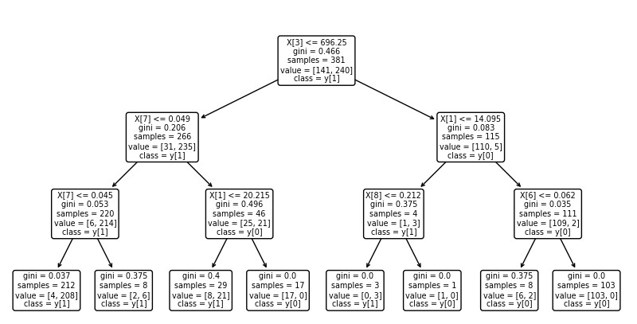

**Random Forest**

|  |  |  |  |  |  |  |  |
| --- | --- | --- | --- | --- | --- | --- | --- |
| **α/α** | **Algorithm** | **Number of Estimators** | **Criterion** | **Accuracy** | **Precision** | **Recall** | **F1** |
| 1 | Random Forest | 95 | entropy | 0.9148 | 0.9153 | 0.9158 | 0.9150 |
| 2 | Random Forest | 100 | entropy | 0.9095 | 0.9109 | 0.9180 | 0.9100 |
| 3 | Random Forest | 105 | entropy | 0.8882 | 0.8886 | 0.9067 | 0.8884 |
| 4 | Random Forest | 95 | gini | 0.9042 | 0.9051 | 0.9186 | 0.9045 |
| 5 | Random Forest | 100 | gini | 0.8989 | 0.8985 | 0.9316 | 0.8984 |
| 6 | Random Forest | 105 | gini | 0.9468 | 0.9472 | 0.9482 | 0.9469 |

1) Accuracy plot 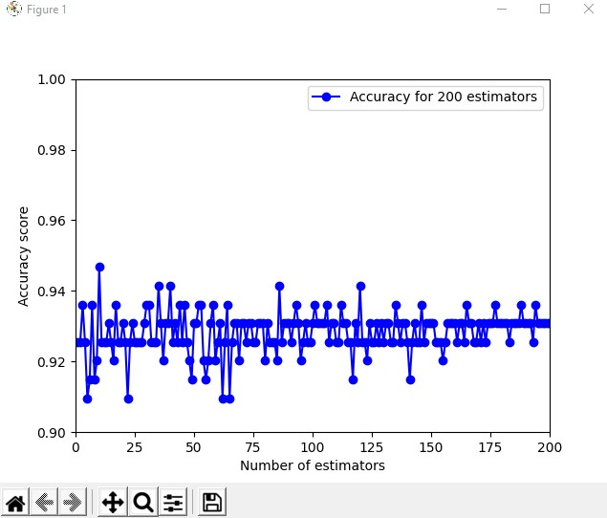

2)Recall plot

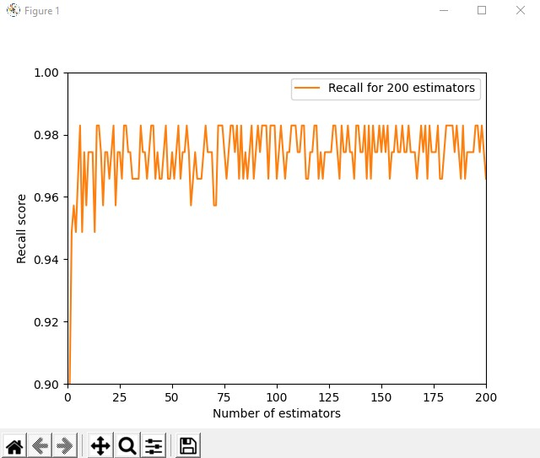

3)Precision plot  
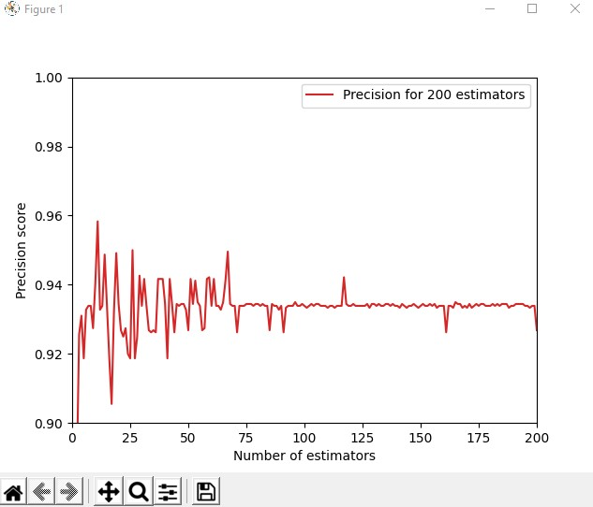

4)F1 plot  
